Why tenants should not seek 100% rent relief under the Commercial Rent (Coronavirus) Act 2022 (‘CRCA’)
On 24 March 2022 the CRCA became law and gave business tenants of properties adversely affected by Covid lockdowns, the right to seek relief from the payment of Covid period rent arrears, provided they had not already reached agreement with their landlord over payment.
There is believed to be over £1bn of such unpaid rent. The industries most affected are pubs, bars & nightclubs, restaurants and clothes shops.
The process of seeking relief is through statutory arbitration. The relief can include writing off some or all of the debt and/or providing for payment over a period of up to 2 years.
The assessment of relief by the arbitrator is based on balancing the principles of:
(a) Preserving, or restoring and preserving, the viability of the business of the tenant, so far as that is consistent with preserving the landlord’s solvency.
(b) That the tenant should, so far as is consistent with (a) be required to meet its obligations as regards the payment of protected rent in full and without delay (s.15(1)).
Viability is deliberately not defined.
There is a “Goldilocks zone” for viability: If the tenant is unviable even if maximum relief is given, then they will get no relief: If the tenant would be viable without relief, then they must pay. Only the green band below can get relief under CRCA.
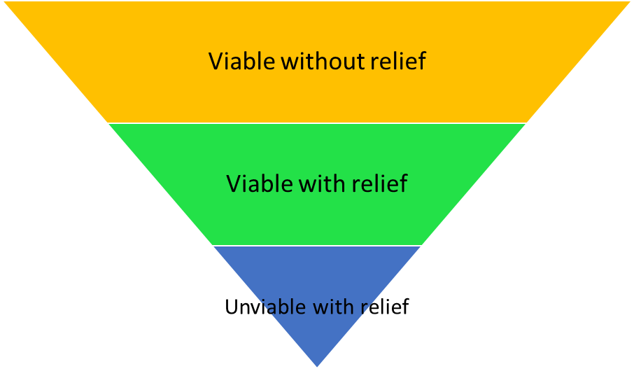

Some tenants may say that they should not pay any rent.
However, it is inherently unlikely that 100% relief from paying the Covid period rent debt is the appropriate level of relief. That would mean that the exact amount of unpaid rent was the perfect figure to ensure viability: If the tenant had to pay any rent at all, then they would not be viable, but they would be viable if 100% relief was given.
The tenant offering nothing runs a substantial risk that they are assessed to be unviable even with maximum relief (the blue zone above).
Therefore, a ‘formal offer’ by the tenant in the CRCA process to pay nothing for the Covid period rent arrears is likely to lack credibility and may lead to no relief being granted.

